**Linux 1 Instance**

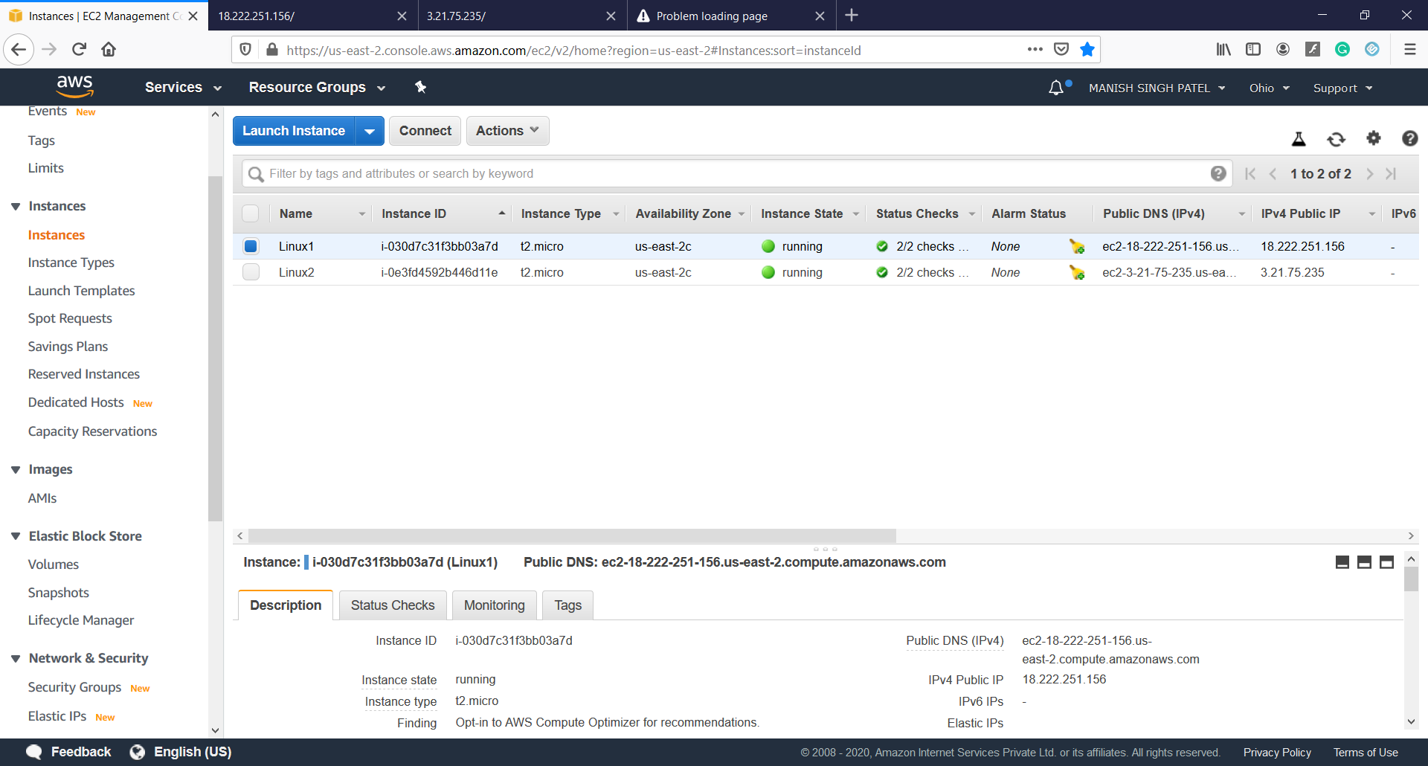

**Linux 2 Instance**

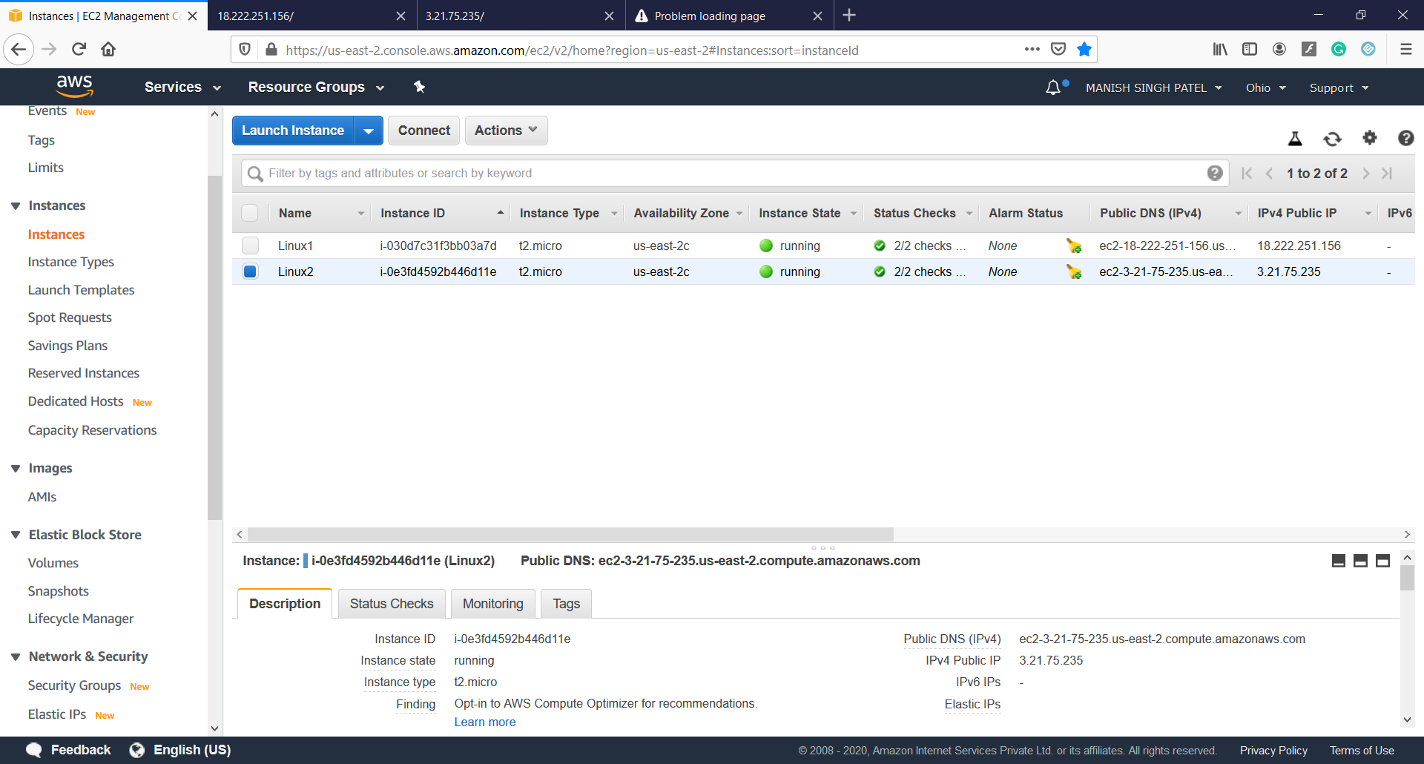

**Linux 1 web server**

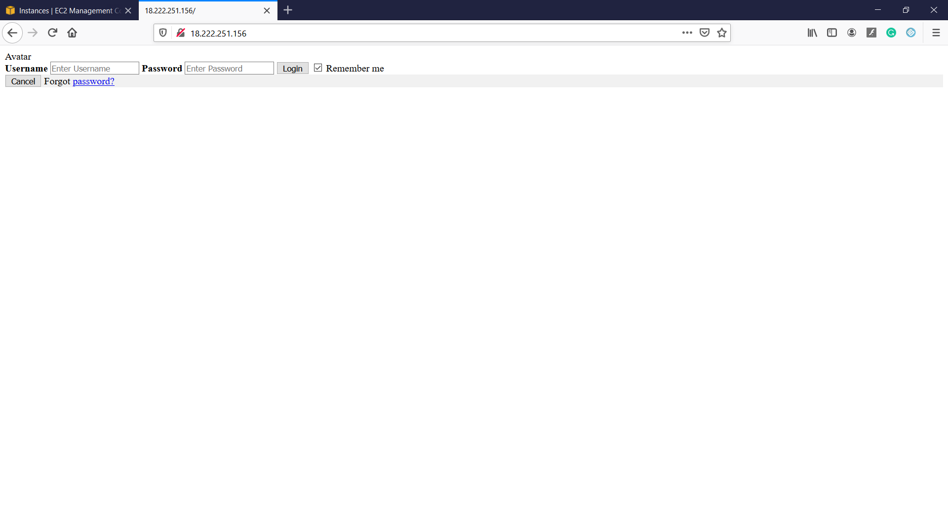

**Linux 2 web server**

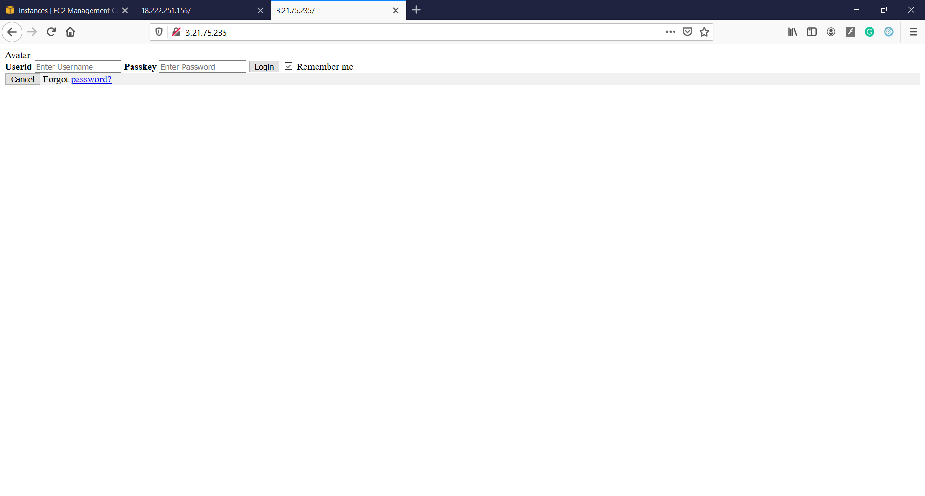

**Load balancer**

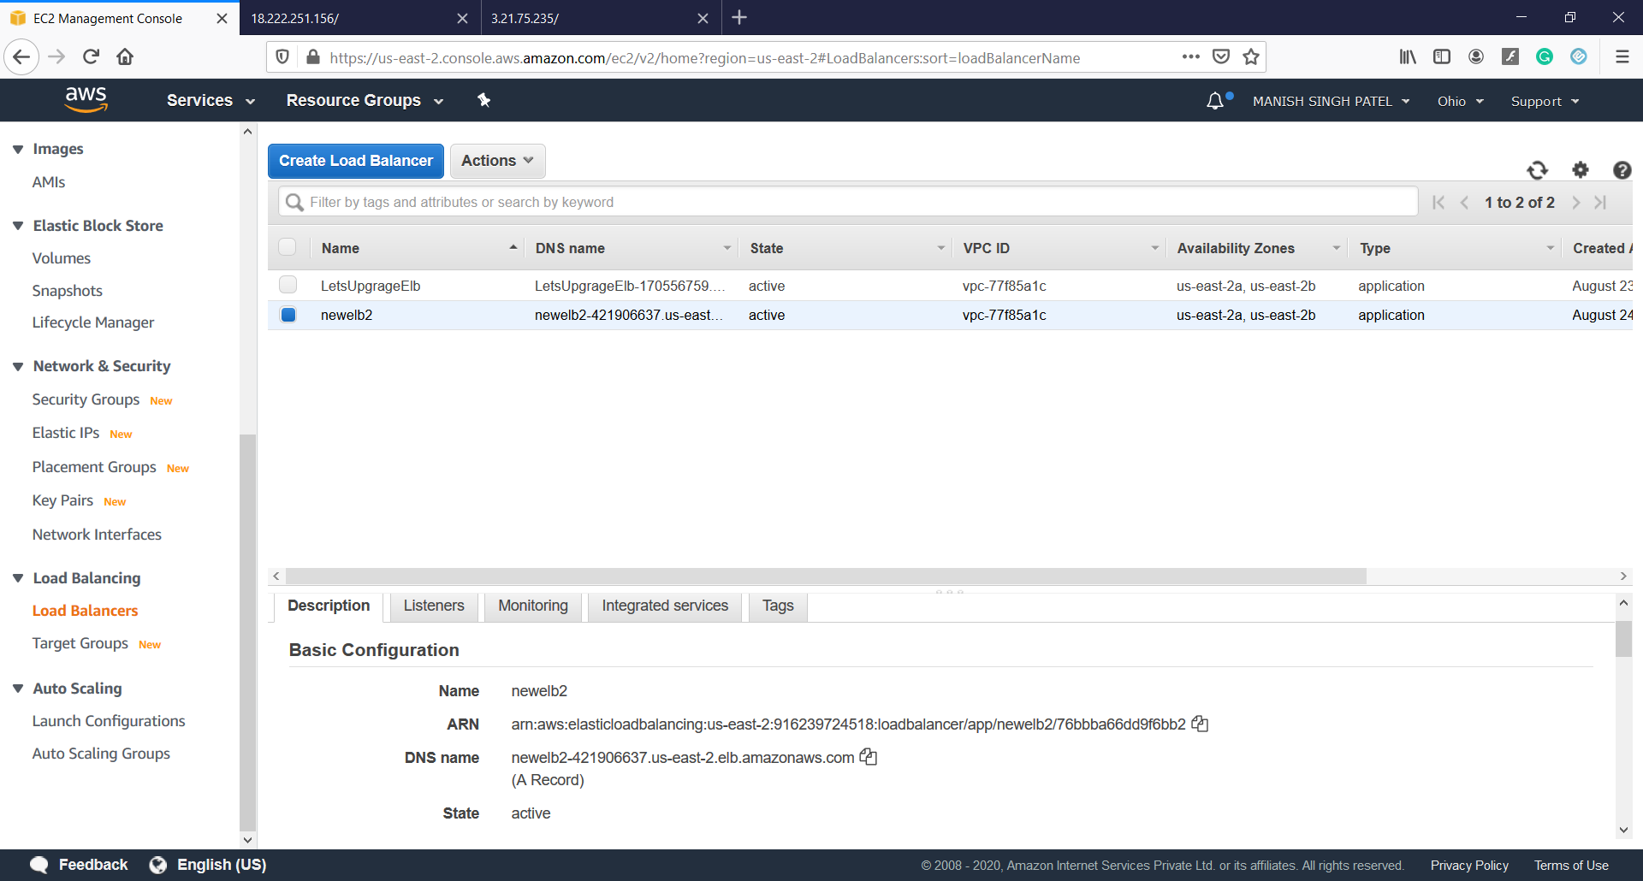

**Load balancer | web page**

**It will take 24 hours to responded till I just attach the file of showing that temporarily unavailable**

